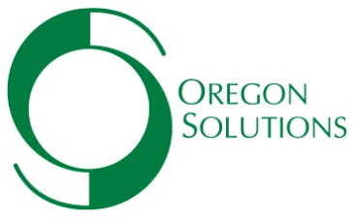 PRE-ASSESSMENT FORM

Thank you for taking a moment to help Oregon Solutions assess whether we can assist you in your project. The information provided below will help expedite our process so that we can respond to requests more quickly.

- Date:

- Project Name:

- Requester (Organization, contact name, phone and e-mail address):

- Please give a brief description of the project. What is the problem or opportunity to be addressed? Is the potential project a priority for the Regional Advisory Committee for the area?

- Is this a new project or is it part of an ongoing effort? If it is part of an ongoing effort, please explain the role of this project as a part of the larger effort.

- Explain how the project could benefit from collaboration of multiple parties (public sector, private sector, and/or non-profit/civic sector).

- What individuals, organizations, and government entities are currently supportive or involved in this project?

- Who are other potential partners in this project?

- What political support is needed for this project to be successful? Are the necessary political supporters (e.g. City Council, School Board) aware of the project? Are they in agreement?

- Describe any current or potential opposition to the project. In your opinion, what would need to happen for the opponents of the project to be supportive?

- If Oregon Solutions was not an option for this project, what alternatives would be considered for moving the project forward?

- List any key timelines and/or deadlines:

- Oregon Solutions’ costs vary depending upon the scope and complexity of the project (which can translate into additional time). Following the initial assessment work, sponsors will receive a total project cost estimate. While Oregon Solutions can provide a portion of the total cost, sponsors are expected to contribute cash needed for the engagement. Please list any potential sources of community/partner funding for the process.

