Lents Stabilization and Job Creation Collaborative – Project Details

- Date: June 10, 2016

- Project Name: Lents Stabilization and Job Creation Collaborative

- Requesters:
State Representative Jeff Reardon
Portland Mayor Charlie Hales

- Brief description of the overall project. What is the problem to be addressed?

The Lents Stabilization and Job Creation Collaborative will build a foundation for improving community stability, equity, natural resource restoration and economic growth in flood-prone areas of the Lents and Powellhurst-Gilbert neighborhoods. These neighborhoods are comprised of largely under-served communities.

For over 75 years, considerable employment and residential development has occurred in Johnson Creek’s 100-year floodplain. Within the Lents and Powellhurst-Gilbert neighborhoods, about 330 acres are designated by FEMA as flood hazard areas. The real and perceived impacts from this designation undermine development and job creation, and significantly burden hundreds of residents with the rising costs of flood insurance. Flooding of Foster Road and industrial land also impacts the health of Johnson Creek.

The Lents Stabilization and Job Creation Project brings together myriad stakeholders to address these issues and improve community conditions in a way that can be replicated in other parts of the region and the state. Few places in region and state offer the same potential to leverage actions toward the triple bottom line of sustainability – economy, equity and environment – in one location.

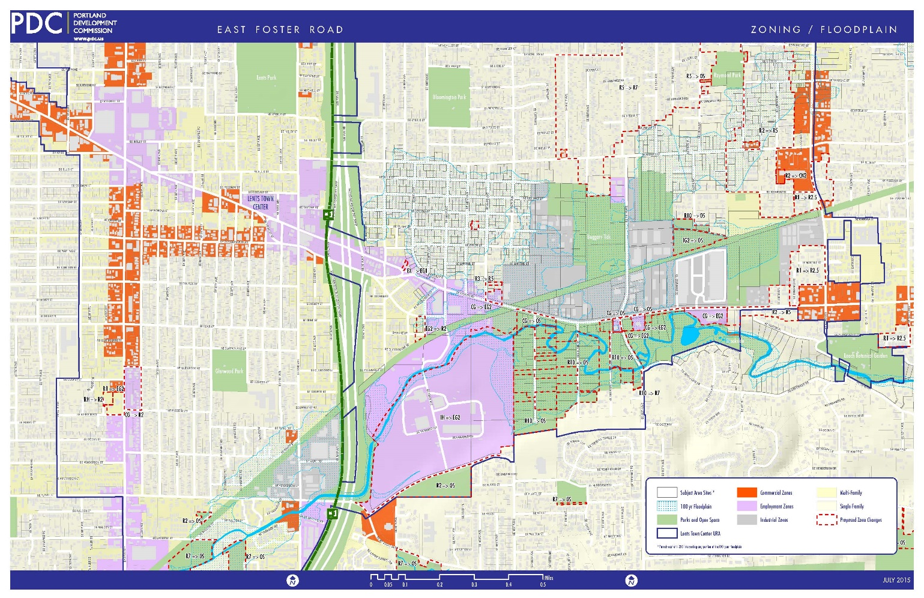
Map 1: Project area, zoning and floodplain

Lents Stabilization is an opportunity for Oregon.
- A framework for stabilizing Lents will be developed that can be applied to flood-prone areas across the region and the state of Oregon.
- A Local Floodplain Mitigation Bank will be the core tool that will allow fill within the developed floodplain in exchange for contributing toward floodplain restoration elsewhere within the district. It is a transferable tool that can be applied in other floodplain areas in the state.

Lents Stabilization is an opportunity for the Region.
- Addressing the impacts of large-scale flooding in Lents will leverage public investments in infrastructure, avoiding pressure at the Urban Growth Boundary.
- Restoring floodplain functions will improve water quality conditions effecting ESA-listed salmonids.
- Addressing impediments to economic investments in Lents and Powellhurst-Gilbert will unlock large and regionally-significant industrial sites. For example, the ‘Freeway Land’ site is one of the largest underdeveloped industrial properties in Portland, with over 60 acres of developable land under a single ownership. This property and other large sites could grow hundreds of traded-sector businesses and create middle-wage jobs that would benefit East Portland and the Portland metro region.

Lents Stabilization is an opportunity to improve equity among an under-served community.
- Lents and Powellhurst-Gilbert are diverse, low-income neighborhoods, with more children and more single parent households than the rest of Portland. Addressing Johnson Creek flooding will reduce the financial burden of flood insurance on these vulnerable households, preventing displacement of existing residents, while preserving housing affordability.
- A Floodplain Mitigation Bank can expand East Portland’s network of trails and natural areas to enhance wildlife habitat and provide recreational opportunities for local residents and the region.

Cost-Benefit Analysis. A 2013 cost-benefit analysis showed the potential economic benefits of the Lents Stabilization and Job Creation Project for areas north of Foster Road (not including Freeway Land), as follows:
- 520 new jobs; $24 million in new wages
- $105 million increase in employment property value
- 400 single-family properties no longer in the floodplain (71 acres)
- 31 acres of multi-family properties no longer in the floodplain
- 60+ acres of industrial land no longer in the floodplain
- 30 acres of additional natural areas

The study estimated initial costs for land acquisition, restoration and street improvements at about $89 million. This did not include potential cost recovery through the Floodplain Mitigation Bank.

Through the Oregon Solutions process, further analysis will refine costs and benefits of the project, including:
- The economic value of the mitigation bank to industrial property owners
- Methods to leverage mitigation bank benefits to offset floodplain restoration costs
- Impacts of not taking action, including:
  - Flooding impacts on regionally-significant industrial and employment lands
  - Development and flooding impacts on watershed health
  - Flood insurance costs on a per-household and area-wide basis
  - Impacts on the local housing market, including affordability and potential displacement
  - Impacts on the demand for industrial sites in the context of pending changes to floodplain regulations
- The market for developable industrial land and potential for job creation, if it is no longer in the floodplain

The Risk of Doing Nothing

Within the project area, 81 acres of employment, industrial and commercial land, and 142 acres of residential property are in the 100-year floodplain. Frequent flooding and revisions to floodplain regulations hamper industrial development. Recent federal actions taken to stabilize FEMA’s budget will result in flood insurance premiums rising to more than triple pre-recession levels. For some homeowners this could mean rates as much as $4,000 a year in an area where the annual per capita income is about $19,500 compared to a Portland average of almost $32,000. Without action, some floodplain homeowners risk losing their homes. If nothing is done, the area’s industrial lands – now dominated by auto salvage yards and recycling – will remain underutilized, low-value industrial lands with scrapped cars stored in areas regularly flooded by Johnson Creek.

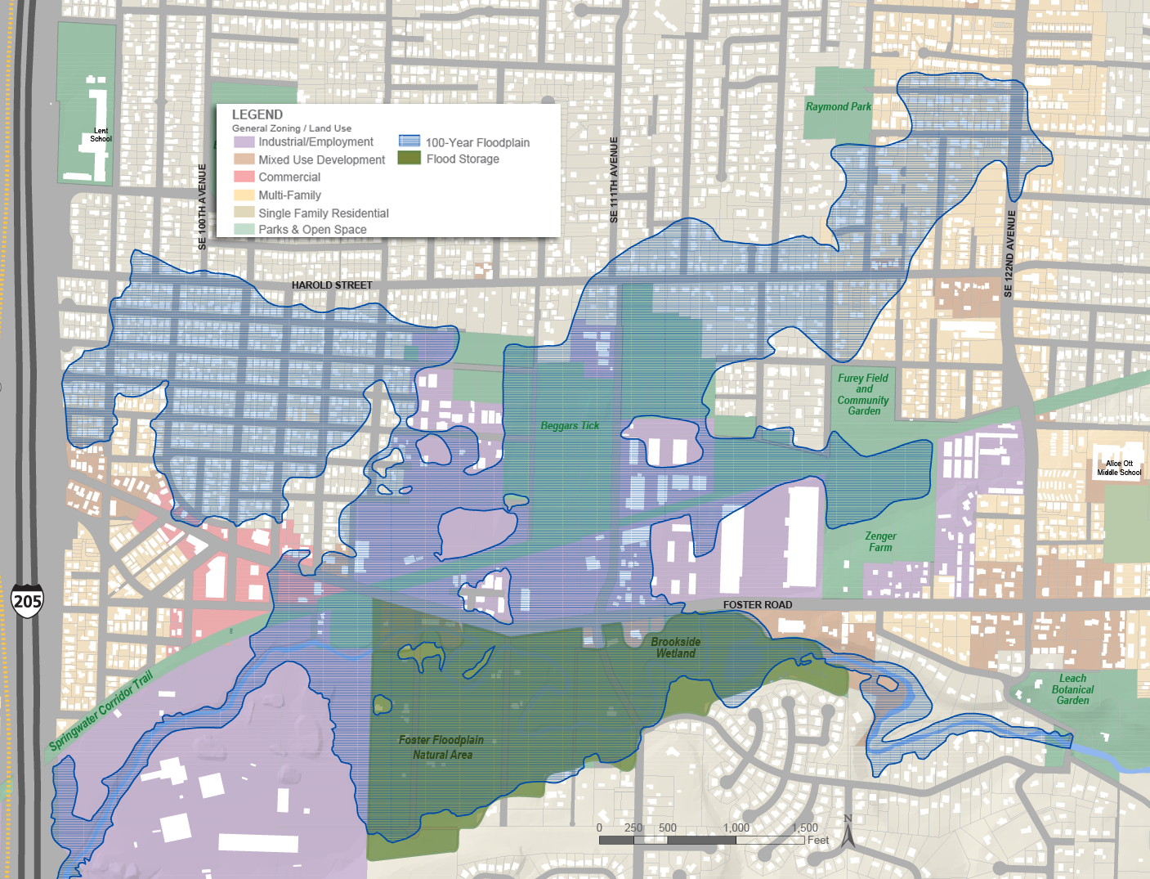
Map 2: Lents 100-year Floodplain – Existing Conditions

Project Elements

Oregon Solutions support is requested to convene a process that engages public, community and business stakeholders in developing a framework upon which to build future efforts. That framework will focus on four areas:

Residential Stabilization (Lead: Portland Housing Bureau) – Despite rapidly-rising housing costs in Portland, property in the Lents and Powellhurst-Gilbert neighborhoods is still relatively affordable. In the floodplain, however, flood insurance costs hamper affordability. To preserve housing affordability for existing residents and prevent displacement, the Oregon Solutions process will support near-term efforts to reduce the burden of flood insurance on homeowners and make long-term recommendations to prevent displacement that could occur if the cost of living increases after the completion of floodplain mitigation.

Industrial Site Readiness (Lead: Portland Development Commission) – Industrial properties in the area are largely underdeveloped despite the area’s proximity to I-205, port facilities and other industrial districts. The Oregon Solutions process will assess the types of constraints to development (such as infrastructure issues or site contamination) and identify paths to revitalize underutilized or dilapidated employment properties to stimulate job growth.

Floodplain Mitigation Bank (Lead: Bureau of Environmental Services) – The expansive floodplain in Lents and Powellhurst-Gilbert neighborhoods dampens the area’s potential as a community and job hub. To support industrial investment, stabilize neighborhoods and capitalize on Johnson Creek as an amenity for the community and the region, the Oregon Solutions process will develop policy and implementation guidance for a local cut-and-fill strategy within the 100-year floodplain. This is a core tool that will facilitate floodplain restoration while allowing industrial properties to fill their properties so they are no longer within the floodplain.

Governance and Funding (Lead: Oregon Solutions) – The project’s multi-disciplinary nature requires expertise from many agencies and organizations; however, project management responsibilities do not fit neatly within any existing organization’s mission. To support the effort’s long-term success, the Oregon Solutions process will investigate and recommend an organizational structure that could support the long-term implementation of the Lents Stabilization and Job Creation project. In addition, while funding sources are available to support specific strategies, a funding approach needs to be developed to support the long-term implementation of the project.

- Is this a new project or is it part of an ongoing effort? If it is part of an ongoing effort, please explain the role of this project?

Lents Stabilization is a new project that pulls from and expands upon past work from several agencies, as listed below. Drawing from this work, the Lents Stabilization effort will examine the fundamental impacts of flooding and the floodplain designation on the area east of I-205. The project will result in a comprehensive set of strategies to stabilize housing costs, improve environmental conditions and promote job growth.

- Endangered Species Act Program (BES, established 1998)
- Foster Corridor Investment Strategy (PDC, 2013)
  - Technical Memorandum: Foster Road Flood Mitigation Concepts (ARUP for BES, 2013)
  - Economic Cost Benefit Analysis and Methodology for Foster Floodplain Redevelopment (Leland for PDC, 2013)
- Johnson Creek Restoration Plan (BES, 2001)
- Lents Urban Renewal (PDC, initiated in 1998)
- Lents Five-Year Action Plan (PDC, 2014)
- Portland Comprehensive Plan Update (BPS, adoption anticipated in 2017)

- How does this project fit the OS criteria (see last page for details)?

- The potential project meets the legislature’s sustainable community objectives (economy, community and environment) and it addresses one or more regional priorities identified by a Regional Advisory Committee (see www.regionalsolutions.oregon.gov for more details).
The Lents Stabilization Project will provide multiple and interrelated benefits for the economy, community and the environment. Developing a local cut-and-fill (floodplain enhancement and flood mitigation) project will support job creation in the district by making underutilized land available for industrial development and business growth. The residential stabilization aspects of the project, along with the cut-and-fill strategy, will enable vulnerable households to remain in the neighborhood, preserving affordable housing. And the project will restore and reestablish floodplain habitat, with connections to Johnson Creek and previously restored sites, including the Foster Floodplain Natural Area. This will enhance fish and wildlife habitat, improve water quality and expand the network of natural areas in East Portland connected along the Springwater Corridor Trail.

- The potential project is consistent with the goals and objectives of the governor and state legislators who represent the area. The politics around the project are favorable. It is also a priority for state and/or federal agencies.
Representative Jeff Reardon established the Lents Stabilization Project; Mayor Charlie Hales endorses the effort and has recommended City of Portland funding to support the Oregon Solutions effort for the next two fiscal years. Project elements will include stabilization of the base of affordable housing (H/CSD), brownfield remediation (Oregon DEQ and Business Oregon), fish and wildlife habitat enhancement (ODFW), industrial land utilization and floodplain management (DLCD, DSL). Several of these agencies have participated in the development of this proposal.

- There is a high level of excitement or enthusiasm for the project. The Regional Solutions Coordinator is enthusiastic about the project.
Multiple City, Regional, State agencies are supportive of the project. Industrial property owners and local residents have voiced strong support for the effort. Bobby Lee is participating in this effort and is supportive of the project.

- There are multiple players involved from the local, state, and federal governments, the private sector, and NGOs. The potential for collaborative problem-solving and implementation planning among the multiple players is very possible. It is unlikely that any single party can solve the problem or implement the project themselves.
The project team currently includes representatives from the City of Portland, Metro, the State of Oregon, the Lents Neighborhood Association and industrial property owners. No single entity at any level of government has responsibility for addressing the impacts of flooding and the 100-year floodplain on property owners, neighborhood revitalization and economic development. This effort will need to be coordinated between state and local agencies to be consistent with FEMA and ESA regulations. The Oregon Solutions process will recommend a governance structure to support continuation of the project.

- The project is ripe for Oregon Solutions to assist. A lot of the basic groundwork has been done and there is a clear definition of the community problem or of the project to be implemented. The outcome is pretty clear to the multiple parties who will be participating on the project team.
Previous analyses determined that with public acquisition of 30 acres of land, along with floodplain enhancements and improvements to Foster Road, it would be feasible to manage floodwaters that currently cover 330 acres of the neighborhood. An economic analysis also determined that the project would yield significant economic benefits in terms of increased property values and job creation. The project team agrees that the primary needs for moving forward on this effort are:
  - Determining near-term strategies to reduce the impacts of high flood insurance costs on vulnerable homeowners
  - Working with environmental permitting agencies to outline a process that will allow a local cut-and-fill strategy within the floodplain
  - Identifying and addressing other impediments to investment in industrial sites
  - Developing an organizational governance structure and a funding strategy to support future work

- It does not involve a substantial amount of controversy, although some controversy is to be expected. There is no need for a mediator or some sort of dispute resolution process in order to proceed. If mediation is needed the project may be appropriate for Oregon Consensus services.
The project will require further development of the flood mitigation concept, which will identify properties for future acquisition through a willing seller program. Previous experience by the Portland Bureau of Environmental Services indicates that though owners of target properties may raise concerns about their properties being identified for acquisition, the willing seller approach is an effective way to acquire land for restoration. The project recognizes issues related to equity among this largely under-served community and will have to identify and implement measures to minimize the risk of gentrification.

- There is a clearly defined lead partner for the project. In addition, there is an individual champion or multiple champions for the project.
The lead partner for this effort is The City of Portland, with support from numerous bureaus and agencies. Representative Jeff Reardon and Lents Neighborhood Association representative (and floodplain resident) Nick Christensen are champions for the project.

- There is a good likelihood that the project is affordable and funds can be found for it. Project sponsors can contribute towards the cost of the Oregon Solutions process and have identified other possible funding sources for implementing the project.
The City of Portland is able to support staff participation from key bureaus. In addition, Mayor Charlie Hales has recommended funding of $460,000 over the next two fiscal years to cover costs of needed analyses or consultant work.

- There is a strong sponsor or sponsors who will lead the project past the signing of the Declaration of Cooperation to full implementation.
The City of Portland is sponsoring this effort through a collaboration between the Mayor’s Office, Portland Development Commission, Bureau of Environmental Services, Portland Housing Bureau and the Office of Management and Finance.

- Explain how the project could benefit from collaboration of multiple parties (public sector, private sector, and/or non-profit/civic sector):

Unlocking the potential of the industrial and residential areas near Foster Road, east of I-205, requires addressing multiple issues simultaneously – flood mitigation, job creation, housing affordability, habitat restoration, climate change, greenspace planning, brownfield remediation and land use. A diverse mix of stakeholders possess the knowledge and resources to address these issues – neighborhood organizations, businesses, public agencies (city, regional, state and federal), and community-based nonprofits. The Oregon Solutions process provides a mechanism for bringing together the necessary expertise, authority and problem-solving capabilities from the public, private and community sectors.

- What individuals, organizations, and government entities are currently supportive or involved in this project?

State of Oregon
Rep Jeff Reardon, Oregon State Legislature
Bobby Lee, Regional Solutions Coordinator, Governor Brown’s Office
Carolyn Meece, Business Oregon
Cheryl Grabham, Oregon Department of Environmental Quality
Christine Shirley, Oregon Department of Land Conservation and Development
Dennis Sigrist, Oregon Emergency Management
Janet Hillock, Business Oregon
Jevra Brown, Oregon Department of State Lands
Joy Vaughan, Oregon Department of Fish and Wildlife
Karen Homolac, Business Oregon
Kim Travis, Oregon Housing and Community Services
Kirk Jarvie, Oregon Department of State Lands
Sierra Gardiner, Business Oregon

Metro
Bob Stacey, Metro Council
Noah Siegel, Metro

City of Portland
Mayor Charlie Hales
Commissioner Nick Fish
Alison Wicks, Portland Development Commission
Andrea Matthiessen, Portland Bureau of Housing
Andy Reed, Portland Development Commission
Elizabeth Edwards, City of Portland Office of Government Affairs
Fred Miller, Office of Management and Finance
Jane Bacchieri, Portland Bureau of Environmental Services
Jillian Detweiler, Office of Mayor Charlie Hales
Ken Rust, Office of Management and Finance
Kurt Creager, Portland Housing Bureau
Leila Aman, Portland Development Commission
Maggie Skenderian, Portland Bureau of Environmental Services
Marie Walkiewicz, Portland Bureau of Environmental Services
Michael Jordan, Bureau of Environmental Services
Patrick Quinton, Portland Development Commission
Tom Armstrong, Bureau of Planning and Sustainability
Michele Crim, Climate Action Program, Portland Bureau of Planning and Sustainability

Multnomah County
Judy Shiprack, Commissioner

Community
Annette Mattson, Portland General Electric, Lents neighborhood advocate
Jesse Cornett, Lents Neighborhood Association Chair
Nick Christensen, Lents Neighborhood Association and floodplain homeowner
Richard Dickenson, Powellhurst-Gilbert Neighborhood Association

Businesses
Dan Klock, Bridgetown Natural Foods
Tom Walsh, Freeway Land Company
Warren Rosenfeld, Freeway Land Company

Other Supporters
Daniel Newberry – Johnson Creek Watershed Council
Michelle Rudd – Attorney, Planning and Sustainability Commission
Robert Liberty, Director of the Urban Sustainability Accelerator, PSU

- Who are other potential partners in this project?

Industrial property owners
Area residents
Lents Grown Business Association
Portland Bureau of Emergency Management
Local community development and land trust organizations
Environmental organizations
Environmental justice organizations
Powellhurst-Gilbert Neighborhood Association
Army Corps of Engineers

- Who are potential beneficiaries of this project?

Lents and Powellhurst-Gilbert Neighborhoods
- Residents
- Business owners
- Floodplain property owners – business, industrial, and residential
- Parks users
- Workers

State of Oregon
- Business Oregon
- Department of Environmental Quality
- Department of Fish and Wildlife
- Department of Land Conservation and Development
- Department of State Lands
- Housing and Community Services
- Office of Emergency Management

Multnomah County
- Department of County Human Services
- Office of Sustainability

Metro
- Parks and Nature
- Planning and Development

City of Portland
- Bureau of Emergency Management
- Bureau of Environmental Services
- Bureau of Maintenance
- Bureau of Planning and Sustainability
- Housing Bureau
- Parks & Recreation
- Portland Development Commission

Federal
- Army Corps of Engineers
- Federal Emergency Management Agency
- National Marine Fisheries

- Is there any additional information or research needed that would be helpful for the project (i.e. economic analysis, demographic research, surveys, or research on alternative models)?

The follow summarizes tasks will be done during the first year of the project in order to provide the foundation for the development and evaluation of potential strategies.

Residential Stabilization
- Analyze the impact of the floodplain designation on the housing market and neighborhood stability, including:
  - Home values
  - Home sales (time on market, home values compared to outside the floodplain)
  - Flood insurance rates
  - Foreclosure rates
  - Demolitions and homes with building violations
  - Housing costs (current and anticipated)
Floodplain Mitigation
- Model and map the properties affected at different flood intervals.
- Summarize relevant regulations within the floodplain.
- Inventory ecological functions and values within the floodplain; characterize the potential ecological benefits of improving floodplain function.
- Review FEMA’s updated cost/benefit analysis protocol for implications for floodplain management and potentially for future hazard mitigation funding.
- Assess the implications of potential soil contamination for floodplain mitigation.
- Determine the likely mitigation that would be required if properties were to develop under existing regulations and according to the recently released NOAA Biological Opinion.
Industrial Site Readiness
- Inventory industrial and employment land ownership, tenants, and business type.
- Analyze impacts of the floodplain on industrial land values and the ability to build and develop land.
- Estimate the additional value to property owners to be out of the floodplain.
- Conduct interviews and/or conduct focus groups with industrial property owners and developers to:
- Assess if the area is meeting the needs and future plans of industrial users and property owners.
- Determine impediments to industrial development, including flooding and flood risk, soil conditions, transportation access, ownership, parcelization, and other needed site improvements.
- Assess the potential costs and implications of the need to raise Foster Road (PDC, PBOT)
- Research, summarize, and make connections with existing local, state, and federal programs and funding to support industrial site readiness efforts.
Governance and Finance
- Assess the potential roles that existing organizations could/would have in long-term project planning and implementation
- Gather information about organizational and financial models used for similar projects

- What political support is needed for this project to be successful? Are the necessary political supporters (e.g. City Council, School Board) aware of the project? Are they in agreement?

State Representative Jeff Reardon is leading this project; the project is endorsed by Portland Mayor Charlie Hales, business and community leaders, city and state agencies, and community organizations.

- Describe any current or potential opposition to the project. In your opinion, what would need to happen for the opponents of the project to be supportive?

Future implementation of flood mitigation/floodplain enhancement will require purchase of private property through a willing seller program. Some property owners may object to having their properties identified for future acquisition, however, the City of Portland’s previous experiences with this type of approach show that a willing seller approach is effective.

- If Oregon Solutions was not an option for this project, what alternatives would be considered for moving the project forward?

Oregon Solutions is the only entity that offers the comprehensive level of support needed to initiate this multi-faceted project. No single local, state or federal entity is responsible for addressing all of the risks and challenges of living or doing business in a floodplain. This work requires a collaborative approach from the public, private and community sectors, and a project management structure to support the work over the long term. Oregon Solutions is uniquely positioned to engage state agencies in determining how to permit and manage a local flood mitigation strategy in a way that stabilizes the residential community and catalyzes job creation. Oregon Solutions has the facilitation and project management expertise to engage multiple stakeholders in identifying strategies for reducing flood insurance costs for local homeowners.

- List any key timelines and/or deadlines:

January – April 2016
- Secure project funding
- Assemble project team
- Refine project scope of work, under the direction of Oregon Solutions

July 2016 – Initiate Oregon Solutions process

July 2016-June 2017 –
- Analyze existing conditions
- Develop guiding principles
- Research best practices
- Begin to identify strategies

July 2017-June 2018 –
- Develop and evaluate alternatives
- Determine governance and finance needs
- Develop recommendations

- Oregon Solutions’ costs vary depending upon the scope and complexity of the project, and following the initial assessment, sponsors will receive a cost estimate for project management. Oregon Solutions can often provide a portion of matching funding needed for our engagement but it is important the project is supported financially by others in addition to Oregon Solutions. Please list any potential sources of community/partner funding for the process.

City of Portland general funds – Oregon Solutions matching funds; funds for project management
Bureau of Environmental Services operating funds – floodplain mitigation tasks
Portland Development Commission urban renewal funds – industrial site readiness tasks
Portland Housing Bureau housing funds – residential stabilization tasks

In addition, the Lents Stabilization Team is pursuing research support from Portland State University’s Institute for Sustainable Solutions. The team will seek other resources, as needed and available, to support the effort.

Based on a Lents homeowner’s reported annual insurance rate of $1,800 a year, calculated at an 18% increase annually over a five year period.

